26. Strain Analysis with the Fry Method
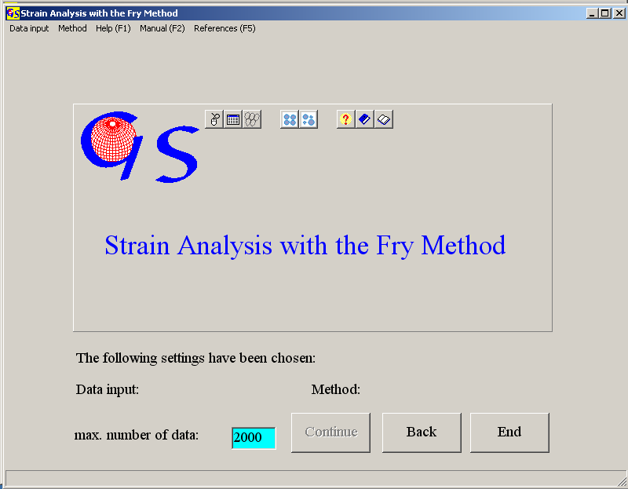
Fig. 1

This program (Fig. 1) carries out a strain analysis according to Fry (1979) and plots a diagram to find the best fit to a finite strain ellipse. The condition for an unambiguous result is a random and isotropic distribution of markers before deformation.
The method can be applied to a plane with markers which changed their mutual position during flattening or shearing. Best results are obtained with randomly distributed markers in a matrix. Pure grain supported farbrics are not suitable for this method.
The program uses the coordinates of centre points for analysis. The classical manual graphic evaluation (Fig. 2) is done as follows: 1) All centre points are plotted on a sheet of paper. 2) A point is drawn on a transparent overlay. This point is centered at all other points successively, and each time all other points are copied on the overlay. The result is an empty elliptical area which does not contain any point. Shape and orientation of this empty area resembles the strain ellipse.
This process was programmed. The user only has to establish the matrix of coordinates of centre-points.
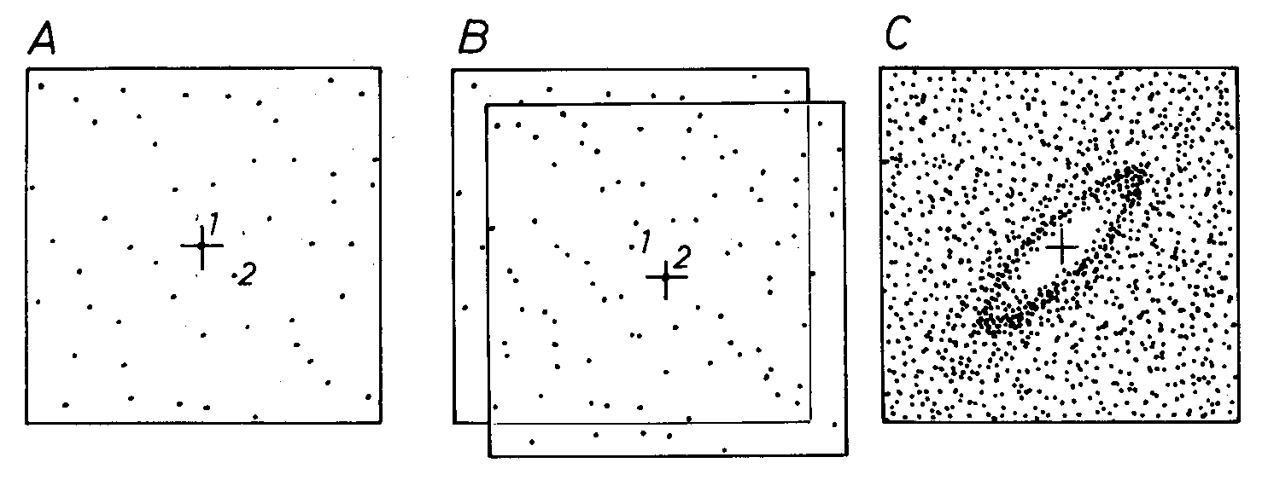Fig. 2
A) Centre the overlay at point 1, copy all other points.
B) Centre the overlay at point 2, copy all other points
C) final diagram.
From Ramsay & Huber (1983).

Data input (Fig. 3) can be done in three ways:

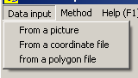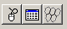
Fig. 3

1) From a picture which exists as a *.bmp- oder *.jpg-file in a directory.
2) From a file which already contains the coordinates of centre-points.
3) From a file which contains the coordinates of corner points of polygons.

In the menu "Method" (Fig. 4) you have to indicate whether only the centre

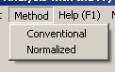
Fig. 4
points of markers shall be used (conventional method), or whether the normalized Fry method shall be applied. In this method the distance between two centres (particle A and B) is devided by the sum of their radii.

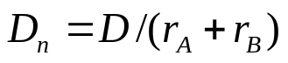

i.e. Particles which are in contact with each other have the normalized distance

D_{n} = 1,

independent of their size (Erslev, 1988). In order to apply this method, the (x,y)-coordinates and the radii of the particles must be known. When a polygon file is used (Fig. 3), the radii are calculated by the program.
When both menus (Data input and method) are clicked, the button "Continue" becomes active. This button brings you to the next form, shown in Fig. 5 after pressing the buttom "Start".
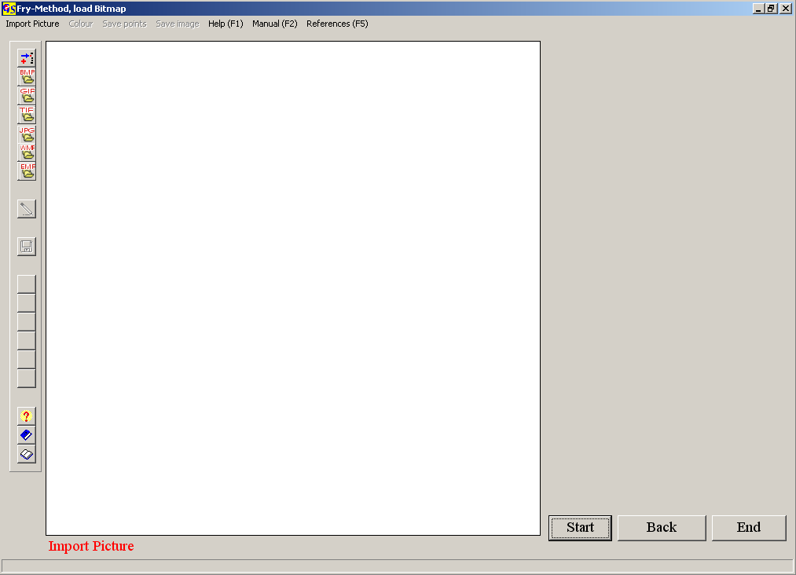
Fig. 5

There are two options for the import of the picture (Fig. 6):

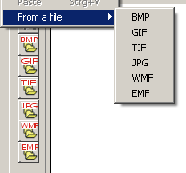
Fig. 6

Click on "Paste" if the picture is already on the clipboard, or click "From a file"
and on "BMP", "GIF", "TIF", "JPG", "WMF", or "EMF" if you want to import a file from a folder. The second option shows the files with the chosen extension in the folder being used (Fig. 7).

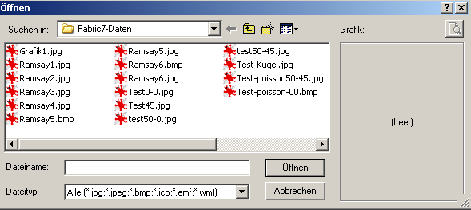
Fig. 7

You can switch to another folder with the usual Windows techniques. Clicking on a file name imports the picture to the screen (Fig. 8). Click on all centres of the markers. With each click the coordinates appear in the list on the right side and the number of points clicked is indicated (Fig. 9).
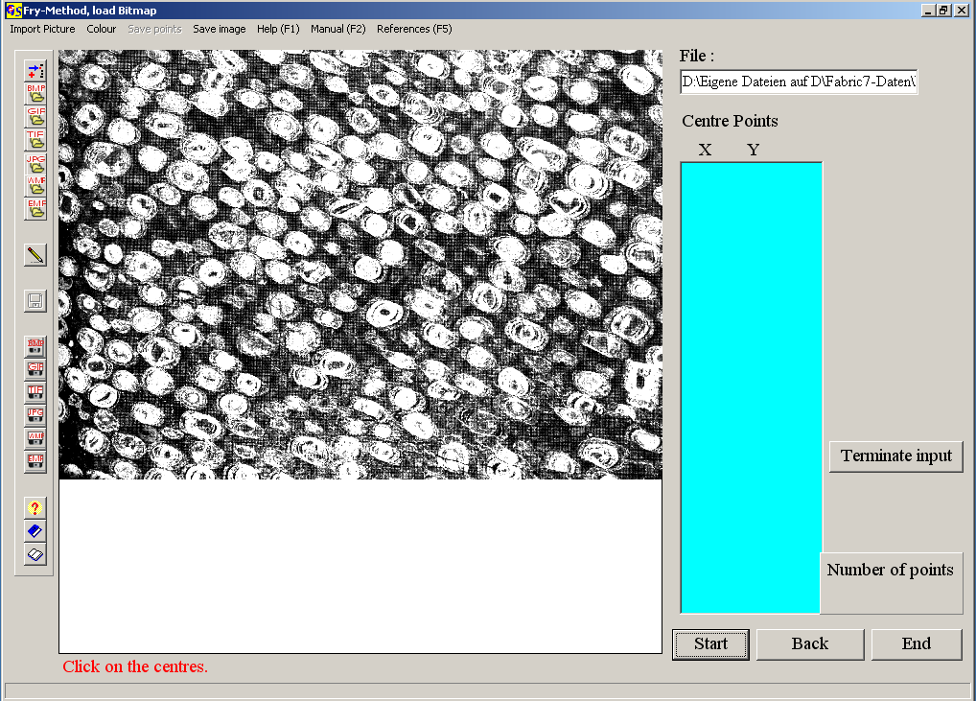
Fig. 8

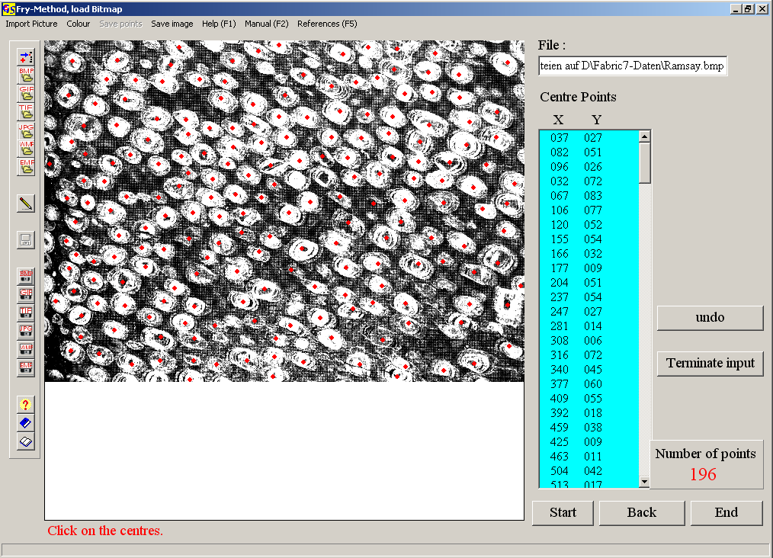
Fig. 9

When you chose the option "Normalized" in menu "Method", you have to click on the centre of a particle and on a point of the periphery. When the particles are elliptical you should click on that point of the periphery which has the shortest distance to the centre. (Fig. 10).
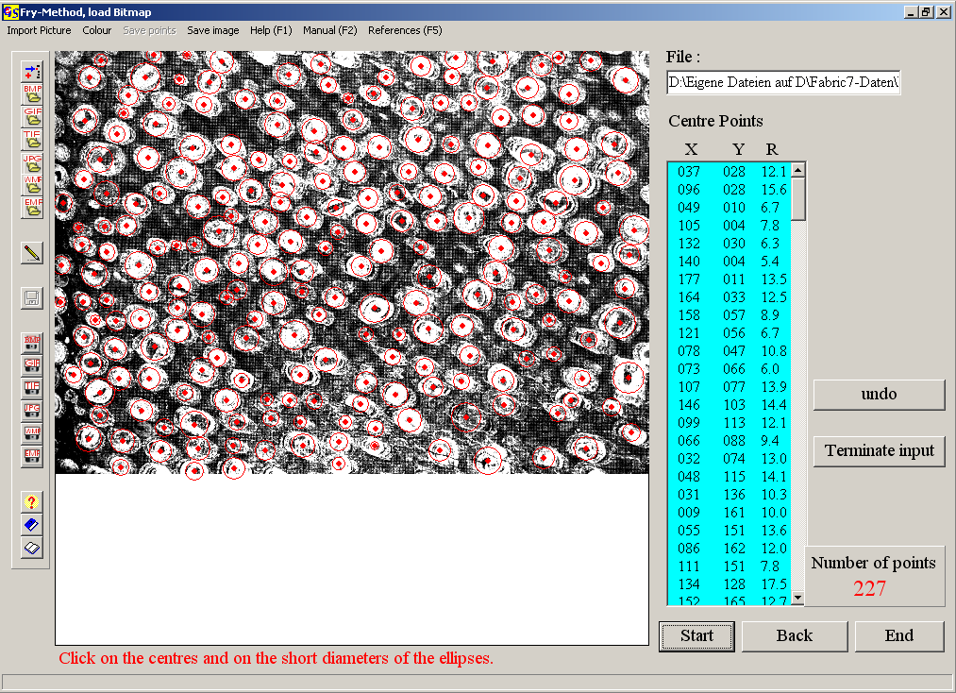Fig. 10

With the menu "Colour" the colour of the points clicked can be changed. With the menu "Save image" the image can be saved as *.BMP-,*.GIF-,*.TIF-, *.JPG-, *.WMF or *.EMF file. Press the button "Terminate input" when all particles have been clicked. Now the menu "Save points" becomes active, and you can save the coordinates and the radii. The button "Plot" becomes visible. This button brings you to the Fry plot (Fig. 11). You come to the same form when data are read from a file.
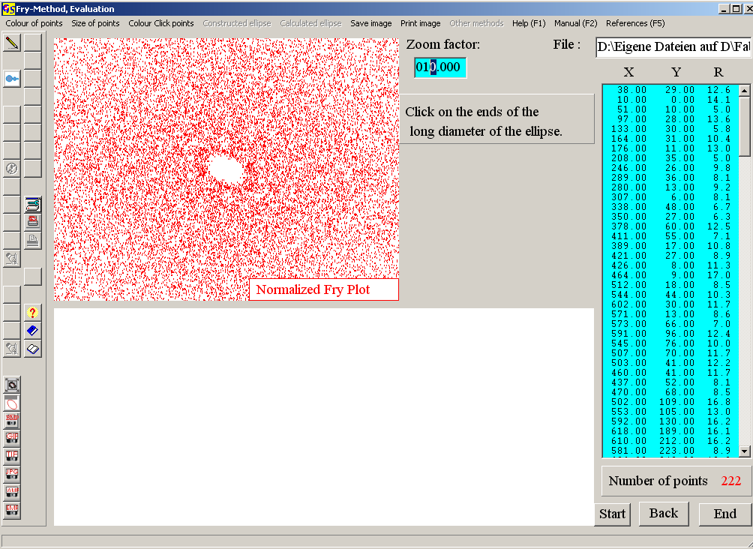
Fig. 11

The shape of the strain ellipse can be found from the empty area in the middle of the plot. The size of this ellipse can be changed by input of another zoom factor. (Fig. 12).

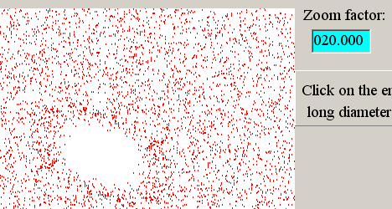
Fig. 12

With the menu "Size of points" you can change the points (Fig. 13).
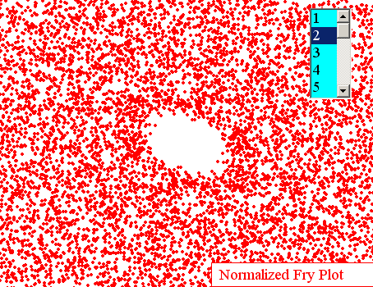
Fig. 13

The evaluation is done interactively:
In a first step you click on the ends of the visually found the long diameter (Fig. 14). then on the ends of the short diameter. The colour of these points is chosen in the menu "Colour of click points".

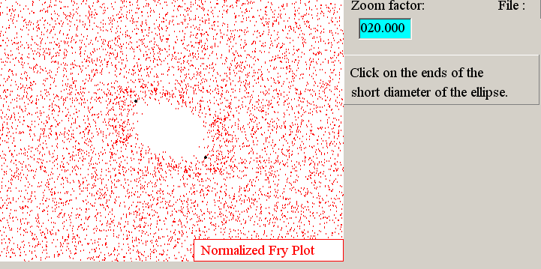
Fig. 14

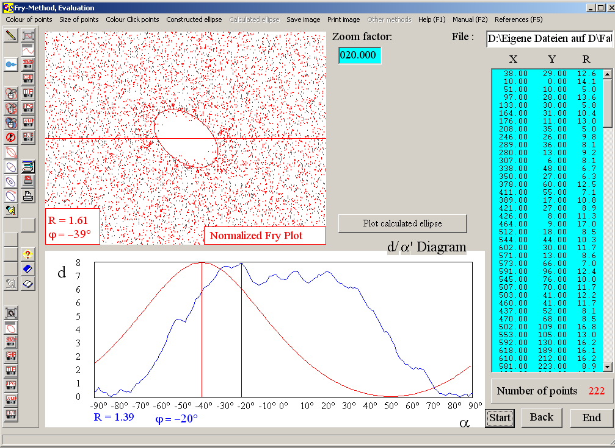Fig. 15

After clicking on both diameters an ellipse with these diameters is drawn (Fig. 15). The ellipticity R (ratio long axis / short axis) and the inclination (ϕ) of the long axis are shown in the left lower corner. ϕ is counted counter clockwise from the horizontal reference line towards the long axis.
Additionally the d'/α'- diagram is drawn, following the centre-to-centre method described by Ramsay & Huber (1983). The graph drawn in the colour of the points of the Fry plot is the reference curve calculated from the diameters and the inclination of the long axis.
The other curve shows the distances between all points plotted against the angle α between the connecting lines of the points and the horizontal reference line.
This is calculated by deviding the angle 180° into sectors of 5°, and find the arithmetic means of the distances in these groups.
In the menu "Constructed ellipse" (Fig. 16) you can improve the fit of the ellipse to the points. Fig. 17 shows the plot after clicking "Colour/,Area/Colour".
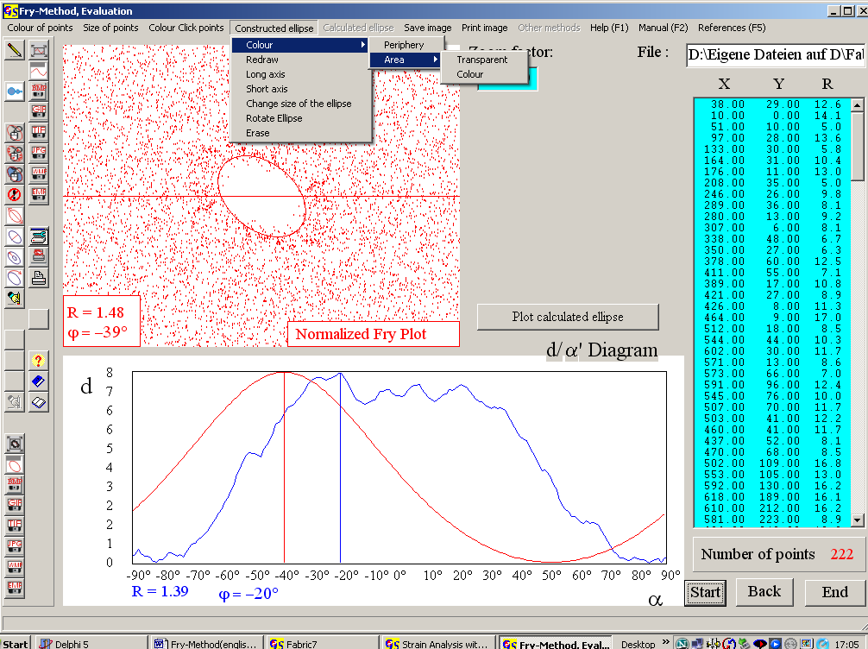
Fig. 16

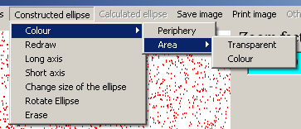Fig. 16
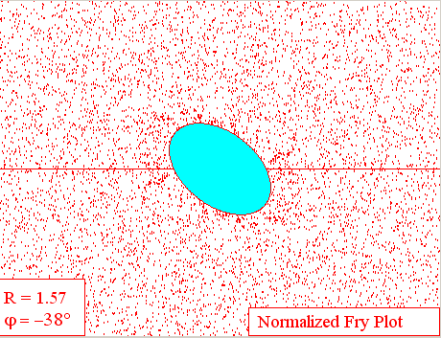
Fig. 17

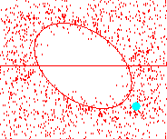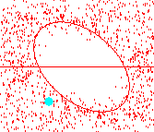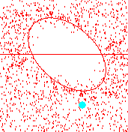
Fig. 18 Fig. 19 Fig. 20

Fig. 18 shows the option "Long axis". When you click with the left mouse button on the point which indicates the long axis and keep the button pressed, you can stretch or pinch the long axis. With the option "Short axis" you can change the short diameter in the same way (Fig. 19). With the option "change size of the ellipse" you can change both axes with their ratio fixed (Fig. 20). When you choose the option "Rotate ellipse" two buttons appear (Fig. 21). Pressing these buttons rotates the ellipse about one degree clockwise or counterclockwise.
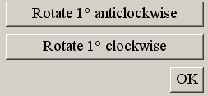
Fig. 21

Rotation is terminated with the button "OK". The new values for R and ϕ are indicated in the left lower corner. With the button "Plot calculated ellipse" an ellipse which is drawn with the values from the d'/α' is plotted into the Fry plot. (Fig. 22).
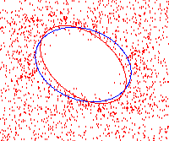
Fig. 22

With the menu "Save image" separate files can be made for the Fry plot and for the d'/α' diagram. The options are described in program 3. With "Print image you can make separate printouts for both diagrams.

